**Oracle Data Guard is the most effective solution available today to protect the core asset of any enterprise—its data, and make it available on a 24x7 basis even in the face of disasters and other calamities.**

Introduction to Oracle Data Guard

Oracle Data Guard ensures high availability, data protection, and disaster recovery for enterprise data.

An **Oracle Data Guard configuration** can contain one primary database and up to thirty destinations.

Oracle Data Guard provides a comprehensive set of services that create, maintain, manage, and monitor one or more standby databases to enable production Oracle databases to survive disasters and data corruptions. Oracle Data Guard maintains these standby databases as copies of the production database. Then, if the production database becomes unavailable because of a planned or an unplanned outage, Oracle Data Guard can switch any standby database to the production role, minimizing the downtime associated with the outage.

You can manage primary and standby databases using either the SQL command-line interface or the Oracle Data Guard broker interfaces. The broker provides a command-line interface (DGMGRL) and a graphical user interface that is integrated in Oracle Enterprise Manager Cloud Control.

#### Primary Database

An Oracle Data Guard configuration contains one production database, also referred to as the primary database, that functions in the primary role.

The primary database is the database that is accessed by most of your applications.

The primary database can be either a single-instance Oracle database or an Oracle Real Application Clusters (Oracle RAC) database.

#### Standby Databases

A standby database is a transactionally consistent copy of the primary database.

Using a backup copy of the primary database, you can create up to thirty standby databases and incorporate them into an Oracle Data Guard configuration. Oracle Data Guard automatically maintains each standby database by transmitting redo data from the primary database and then applying the redo to the standby database.

**Physical standby database**

A physical standby database is an exact, block-for-block copy of a primary database.

A physical standby is maintained as an exact copy through a process called Redo Apply, in which redo data received from a primary database is continuously applied to a physical standby database using the database recovery mechanisms.

A physical standby database can be opened for read-only access and used to offload queries from a primary database. If a license for the Oracle Active Data Guard option has been purchased, Redo Apply can be active while the physical standby database is open, thus allowing queries to return results that are identical to what would be returned from the primary database. This capability is known as the real-time query feature.

Benefits of a Physical Standby Database

A physical standby database provides the following benefits:

* Disaster recovery and high availability

A physical standby database is a robust and efficient disaster recovery and high availability solution. Easy-to-manage switchover and failover capabilities allow easy role reversals between primary and physical standby databases, minimizing the downtime of the primary database for planned and unplanned outages.

* Data protection

A physical standby database can prevent data loss, even in the face of unforeseen disasters. A physical standby database supports all datatypes, and all DDL and DML operations that the primary database can support. It also provides a safeguard against data corruptions and user errors. Storage level physical corruptions on the primary database are not propagated to a standby database. Similarly, logical corruptions or user errors that would otherwise cause data loss can be easily resolved.

* Reduction in primary database workload

Oracle Recovery Manager (RMAN) can use a physical standby database to off-load backups from a primary database, saving valuable CPU and I/O cycles.

A physical standby database can also be queried while Redo Apply is active, which allows queries to be offloaded from the primary to a physical standby, further reducing the primary workload.

* Performance

The Redo Apply technology used by a physical standby database is the most efficient mechanism for keeping a standby database updated with changes being made at a primary database because it applies changes using low-level recovery mechanisms which bypass all SQL level code layers.

**Logical standby database**

A logical standby database is initially created as an identical copy of the primary database, but it later can be altered to have a different structure.

The logical standby database is updated by executing SQL statements. The flexibility of a logical standby database lets you upgrade Oracle Database software (patch sets and new Oracle Database releases) and perform other database maintenance in rolling fashion with almost no downtime. The transient logical database rolling upgrade process can also be used with existing physical standby databases.

Oracle Data Guard automatically applies information from the archived redo log file or standby redo log file to the logical standby database by transforming the data in the log files into SQL statements and then executing the SQL statements on the logical standby database. Because the logical standby database is updated using SQL statements, it must remain open. Although the logical standby database is opened in read/write mode, its target tables for the regenerated SQL are available only for read-only operations. While those tables are being updated, they can be used simultaneously for other tasks such as reporting, summations, and queries.

A logical standby database has some restrictions on data types, types of tables, and types of DDL and DML operations.

Benefits of a Logical Standby Database

A logical standby database is ideal for high availability (HA) while still offering data recovery (DR) benefits. Compared to a physical standby database, a logical standby database provides significant additional HA benefits:

* Minimizing downtime on software upgrades

A logical standby database is ideal for upgrading an Oracle Data Guard configuration in a rolling fashion. Logical standby can be used to greatly reduce downtime associated with applying patchsets and new software releases. A logical standby can be upgraded to the new release and then switched over to become the active primary. This allows full availability while the old primary is converted to a logical standby and the patchset is applied. Logical standbys provide the underlying platform for the DBMS_ROLLING PL/SQL package, which provides functionality that allows you to make your Oracle Data Guard configuration highly available in the context of rolling upgrades and other storage reorganization.

* Support for reporting and decision support requirements

A key benefit of logical standby is that significant auxiliary structures can be created to optimize the reporting workload; structures that could have a prohibitive impact on the primary's transactional response time. A logical standby can have its data physically reorganized into a different storage type with different partitioning, have many different indexes, have on-demand refresh materialized views created and maintained, and can be used to drive the creation of data cubes and other OLAP data views. However, a logical standby database does not allow for any transformation of your data (such as replicating only a subset of columns or allowing additional columns on user tables). For those types of reporting activities, Oracle GoldenGate is Oracle's preferred solution.

**Snapshot Standby Database**

A snapshot standby database is a fully updatable standby database.

Like a physical or logical standby database, a snapshot standby database receives and archives redo data from a primary database. Unlike a physical or logical standby database, a snapshot standby database does not apply the redo data that it receives. The redo data received by a snapshot standby database is not applied until the snapshot standby is converted back into a physical standby database, after first discarding any local updates made to the snapshot standby database.

A snapshot standby database is best used in scenarios that require a temporary, updatable snapshot of a physical standby database. For example, you can use the Oracle Real Application Testing option to capture the database workload on a primary and then replay it for test purposes on the snapshot standby. Because redo data received by a snapshot standby database is not applied until it is converted back into a physical standby, the time needed to recover from a primary database failure is directly proportional to the amount of redo data that needs to be applied.

Benefits of a Snapshot Standby Database

A snapshot standby database is a fully updatable standby database that provides disaster recovery and data protection benefits that are similar to those of a physical standby database. Snapshot standby databases are best used in scenarios where the benefit of having a temporary, updatable snapshot of the primary database justifies the increased time to recover from primary database failures.

The benefits of using a snapshot standby database include the following:

* It provides an exact replica of a production database for development and testing purposes, while maintaining data protection at all times. You can use the Oracle Real Application Testing option to capture primary database workload and then replay it for test purposes on the snapshot standby.
* It can be easily refreshed to contain current production data by converting to a physical standby and resynchronizing.

The ability to create a snapshot standby, test, resynchronize with production, and then again create a snapshot standby and test, is a cycle that can be repeated as often as desired. The same process can be used to easily create and regularly update a snapshot standby for reporting purposes where read/write access to data is required.

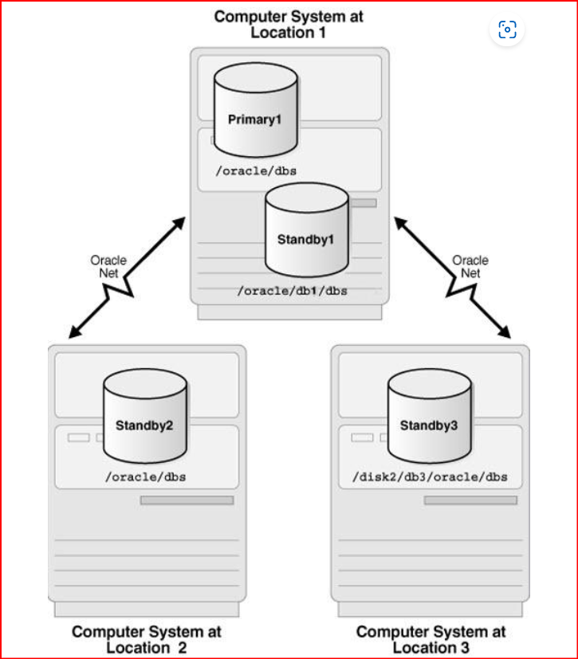

#### Far Sync Instances

An Oracle Data Guard far sync instance is a remote Oracle Data Guard destination that accepts redo from the primary database and then ships that redo to other members of the Oracle Data Guard configuration.

A far sync instance manages a control file, receives redo into standby redo logs (SRLs), and archives those SRLs to local archived redo logs, but that is where the similarity with standbys ends. A far sync instance does not have user data files, cannot be opened for access, cannot run redo apply, and can never function in the primary role or be converted to any type of standby database.

Far sync instances are part of the Oracle Active Data Guard Far Sync feature, which requires an Oracle Active Data Guard license.

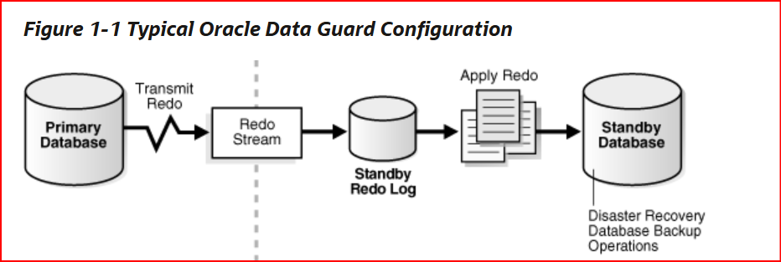

Oracle Database 23ai introduces several new features for Data Guard for Pluggable Databases (DG PDB). They include:

* Simplified setup and management of DG PDB operations.
* The Database Configuration Assistant (DBCA) now supports PDB operations in a Data Guard environment. It is possible to create a PDB from Default (PDB$SEED), a local clone of a PDB, and a remote PDB clone.
* New DBMS_DG APIs are introduced for performing common DG PDB operations.
* All temp file related DDLs supported on a normal CDB are supported for a DG PDB.
* Functionality with Clusterware for PDB service manipulation and application continuity has been added.

### User Interfaces for Administering Oracle Data Guard Configurations

Oracle Data Guard provides several interfaces that you can use to configure, implement, and manage an Oracle Data Guard configuration.

* Oracle Enterprise Manager Cloud Control

Oracle Enterprise Manager Cloud Control provides a GUI interface for the Oracle Data Guard broker that automates many of the tasks involved in creating, configuring, and monitoring an Oracle Data Guard environment. See the Oracle Enterprise Manager Cloud Control online Help for information about the GUI and its wizards.

* SQL*Plus Command-line interface

Several SQL*Plus statements use the STANDBY keyword to specify operations on a standby database. Other SQL statements do not include standby-specific syntax, but they are useful for performing operations on a standby database.

* Initialization parameters

Several initialization parameters are used to define the Oracle Data Guard environment.

* Oracle Data Guard broker command-line interface (DGMGRL)

The DGMGRL command-line interface is an alternative to using Oracle Enterprise Manager Cloud Control. The DGMGRL command-line interface is useful if you want to use the broker to manage an Oracle Data Guard configuration from batch programs or scripts.

### Summary of Oracle Data Guard Benefits

Oracle Data Guard provides an efficient and comprehensive disaster recovery and high availability solution.

Oracle Data Guard offers these benefits:

* High availability

Oracle Data Guard’s easy-to-manage switchover and failover capabilities allow role reversals between primary and standby databases, minimizing the downtime of the primary database for planned and unplanned outages.

* Complete data protection

Oracle Data Guard can ensure zero data loss, even in the face of unforeseen disasters. A standby database provides a safeguard against unplanned outages of all types, including data corruption and administrative error. Because the redo data received from a primary database is validated at a standby database, physical corruptions that can occur at a primary database are not propagated to the standby database. Additional validation performed at a standby database also prevents logical intra-block corruptions and lost-write corruptions from propagating to the standby. Similarly, administrative errors such as accidental file deletions by a storage administrator are not propagated to a standby database. A physical standby database can also be used to protect against user errors either by delaying the redo apply or by using Flashback Database to rewind the standby and extract a good copy of the data.

* Efficient use of system resources

The standby database tables that are updated with redo data received from the primary database can be used for other tasks such as backups, reporting, summations, and queries, thereby reducing the primary database workload necessary to perform these tasks, saving valuable CPU and I/O cycles.

* Flexibility in data protection to balance availability against performance requirements

Oracle Data Guard offers maximum protection, maximum availability, and maximum performance modes to help enterprises balance data availability against system performance requirements.

* Automatic gap detection and resolution

If connectivity is lost between the primary and one or more standby databases (for example, due to network problems), then redo data being generated on the primary database cannot be sent to those standby databases. After a connection is reestablished, the missing archived redo log files (referred to as a gap) are automatically detected by Oracle Data Guard, which then automatically transmits the missing archived redo log files to the standby databases. The standby databases are synchronized with the primary database, without manual intervention by the DBA.

* Centralized and simple management

The Oracle Data Guard broker provides a graphical user interface and a command-line interface to automate management and operational tasks across multiple databases in an Oracle Data Guard configuration. The broker also monitors all of the systems within a single Oracle Data Guard configuration.

* Integration with Oracle Database

Oracle Data Guard is a feature of Oracle Database Enterprise Edition and does not require separate installation.

* Automatic role transitions

When fast-start failover is enabled, the Oracle Data Guard broker automatically fails over to a synchronized standby site in the event of a disaster at the primary site, requiring no intervention by the DBA.